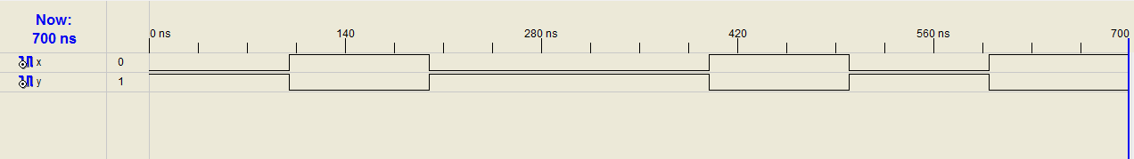

library IEEE;

use IEEE.STD_LOGIC_1164.ALL;

use IEEE.STD_LOGIC_ARITH.ALL;

use IEEE.STD_LOGIC_UNSIGNED.ALL;

---- Uncomment the following library declaration if instantiating

---- any Xilinx primitives in this code.

--library UNISIM;

--use UNISIM.VComponents.all;

entity iqbal1bal is

Port ( x : in STD_LOGIC;

y : out STD_LOGIC);

end iqbal1bal;

architecture Behavioral of iqbal1bal is

begin

y <= not x;

end Behavioral;